Chapter-6 Random Number Generation and Lookup functions
6.1 Introduction
Production of many kinds of fractals requires generation of random number sequences. Depending on the fractal, these numbers have to come from different probability distributions. Purpose of this chapter is to introduce the theoretical basis of such random number generation and describing the way to produce such number sequences in Excel. The usefullness of the concept introduced in this chapter goes far beyond the production of random fractals. It can be used for better understanding of some of the concepts in probability theory and statistics. If you are a +2 student , engineering or commerce student, you might have come across formulas like 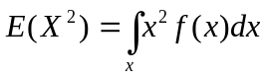, 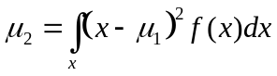 etc and for uniform distribution U(0,1) 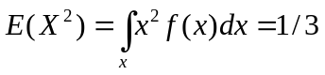.. What exactly is the meaning of this statement ?. Can you give an intuitive interpretation without using any scientific jargon. Explanation based on Generation of random numbers from respective distributions give a clear , intuitive meaning and interpretation of any such statement.
6.2 Random numbers and simulation
Probability and statistics is one of the foundational stone of modern scientific edifice. Randomness pervades everywhere. It is built into nature. No two objects including human beings are identical. Large number of individually insignificant random phenomenon together influences every process occurring in nature. Therefore to model any process, we need to introduce randomness in the system and we do this by generating random numbers. For example a signal received through electronic device usually is corrupted by noise (electromagnetic interference) . So to model a corrupted received signal, we add random noise (random numbers) to the original signal. This will help us to test efficacy of our noise removal algorithm through simulation studies.
Random simulation is a very popular and a well studied field of Mathematics. There exists a wide range of applications in biology, finance, insurance, physics and many others. So generation of random numbers are crucial.
Random numbers can come from different probability distributions. They appear in two families. One group belongs to family of discrete distribution and the other continuous distributions. Uniform distribution in any range (a,b) , Gaussian distribution, exponential distribution etc are examples of continuous distributions where as Binomial, Poisson, geometric etc are discrete distributions.
6.2.1 Uniform Random Numbers

Uniform Random numbers are numbers that occur in a sequence such that two conditions are met: (1) the values are uniformly distributed over a defined interval or set, and (2) it is impossible to predict future values based on past or present ones.
The most common set from which random numbers are derived is the set of single-digit decimal numbers {0, 1, 2, 3, 4, 5, 6, 7, 8, 9}. The task of generating random digits from this set is not trivial. A common scheme is the selection (by means of a mechanical escape hatch that lets one ball out at a time) of numbered ping-pong balls from a set of 10, one bearing each digit, as the balls are blown about in a container by forced-air jets. This method is popular in lotteries. After each number is selected, the ball with that number is returned to the set, the balls are allowed to blow around for a minute or two, and then another ball is allowed to escape.
Sometimes the digits in the decimal expansions of irrational numbers are used in an attempt to obtain random numbers. Most whole numbers have irrational square roots, so entering a string of six or eight digits into a calculator and then hitting the square root button can provide a sequence of digits that seems random. Other algorithms have been devised that supposedly generate random numbers. The problem with these methods is that they violate condition (2) in the definition of randomness. The existence of any number-generation algorithm produces future values based on past and/or current ones. Digits or numbers generated in this manner are called pseudorandom.

6.2.2 Pseudo random number generators
The basic building block for generating pseudo random numbers from various distributions is a generator of uniform random numbers on the interval (0,1), i.e. from the distribution U(0,1). How is this accomplished? Due to the finite precision of computers, we cannot generate a true continuous random variate. However, we will generate a discrete random variate which behaves very close to U(0,1). There is a very rich literature on the generation of random integers, commonly called pseudorandom numbers because they are actually deterministic. Pseudorandom numbers can be divided by their upper bound to generate U(0,1) variates. Here is an example (in pseudo code): Do not bother it now if you don’t know computer programming language.
int U01( )
C = 25173
D = 13849
M = 32768
static Seed
Seed = (C*Seed + D) % M ; % M stands for modulo M or remainder
; when divided by M
return Seed/((float) M)

Excel’s inbuilt function rand( ) returns uniform random number between 0 and 1. The distribution is uniform in the sense that every number in the range 0 and 1 (with in the finite precision allowed by the computer) has the equal likelihood of occurrence. Using uniform random numbers we can generate random numbers from other distributions.
Experiment No: 1 Generate 5 Uniform random numbers in Excel.
Step 1: In cell A1 type =rand( ) and pull the fill handle to A5
Step: 2 Press function key F9 (see it on the top row of keyboard) and notice that all generated numbers change when Function key F9 is pressed. This facility is utilized in many simulation applications. See figure 6.1
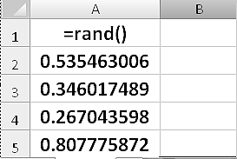
Fig 6.1 Generation of uniform random numbers
In some application we may not want the random number to change once the random numbers are generated. But in Excel any update in a cell will cause the value in the cells where rand( ) function is used. There is no way to stop this. One way to overcome this is to copy the values of random numbers to another location. While pasting we must choose ‘paste only values’ option. The numbers in the copied cell will not change further.
Experiment No: 2 Generate 5 Uniform random numbers in Excel and copy values to location B1:B5.
Step 1 : In cell A1 type =rand( ) and pull the fill handle to A5
Step 2: Select cells A1:A5 and right click the mouse and choose copy. Notice a circling dotted lines appeared around the selected cells you have copied
Step 3 : Select cell B1 , right click the mouse , choose “paste special” and then choose “values” (see figure 6.2)
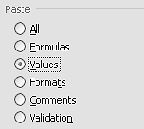
Figure 6.2 Cut/copy spaste_special options in Excel
Step 4: Press Esc (escape) key to remove the data from clipboard. Now notice also that circlinng dotted lines around cells A1:A5 has vanished.
Step 5: Press Function Key F9. Notice that only values in A1:A5 are changing.

Experiment No: 3 Using rand( ) function generate uniform random numbers in the range 3.1 to 4.3 (or in general a to b) .
Since the required random numbers are again uniform, what we need to do is only a mapping from range (0,1) to (a , b) . If x is the random number generated in (0,1), the mapped random number y is a + (b-a) x so that if x =0, y is a and if x = 1 , y is a+(b-a) = b . So the required formula to generate uniform random numbers in the range 3.1 to 4.3 is = 3.1+(4.3-3.1)*rand( ) or = 3.1+1.2*rand( )
INT function
INT function returns integer part of the number given to it as argument. For example =int(5.3) return 5 . Note, it always return a number less than or equal to the given number. So for -5.3 it returns -6. That is =int(-5.3) returns -6
COUNTIF Function
Countif function help us to count number of numbers in a range that satisfy a given criteria. Its format is =countif(cellrange,criteria). Examples of this function calls with criteria are as follows:
=countif(A1:A10, 5) . This count number of 5s in the range A1:A10
=countif(A1:A10, B1) . Let the content of B1 is 5. Then this count number of 5s in the range A1:A10
=countif(A1:A10, “<=”&5) . This count number of numbers which are less than or equal to 5 in the range A1:A10
countif(A1:A10, “<=”&B1) . Let the content of B1 is 5. Then this count number of numbers which are less than or equal to 5 in the range A1:A10
Experiment No: 4. Generate 100 integer random numbers (uniform) between 1 and 5 using U(0,1) random numbers and count the number of occurrence of each integer number.
Rand function returns a number between 0 and 1 . However it will not return the number 0 or 1 . Therefore the formula =int(rand( )*5 ) return an integer number from the set {0,1,2,3,4}. So to get integer numbers in the range 1 to 5 , we add 1 to this formula.
Step 1: Enter titles R.Num in A1, Num in B1 and Count in C1
Step 2 enter formula =1+ int( rand( )*5 ) in cell A2 and copy till A102
Step 2: enter 1 to 5 in the range B2 to B6. This is to use as argument for countif function.
Step 3: enter the formula =countif($A$2:$A$101,B2) in cell C2 and drag the formula till C6 using fill handle.
Step 4: enter string ‘sum’ in cell B7 and enter formula =sum(c2:c6) in C7
Step 5: press function key F9 and see that numbers in columns A and C are changing.
The output will look like as follows in figure 6.3. Note that absolute referencing is used for range A2:A101 so that pulling down the formula will not change the range from which we count the numbers.
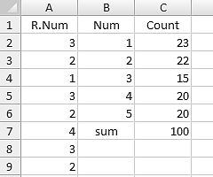
Figure 6.3 Output of Experiment No:4
6.3 Generating random numbers from discrete distributions
Suppose we want to generate random numbers from non-uniform discrete distribution X with probability mass function like the one given in table 6.1, how can we use rand( ) function to generate them.
Table 6.1 : Probability mass function
x | 1 | 2 | 3 | 4
P(x) | 0.15 | 0.3 | 0.4 | 0.15
The problem is that we should generate numbers randomly from the set {1,2,3,4} such that 1 occurs 15% of times 2 occurs 30% of times etc.
We know rand( ) function generate numbers in the range 0,1 with equal likelihood. So to achieve our goal, we may divide the range 0 to 1 into four parts(or bins) in with width in proportion to the probability mass function and associate our integer variable to them as in the following figure. 6.4
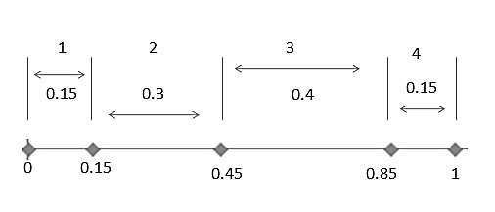
Figure 6.4 : Division of range (0,1) into several intervals in proportion to probability mass function.
So our logic for generating random numbers from discrete distribution is as follows.
Generate a uniform random number using rand( ) function. If it is less than 0.15 assign 1, if it is between 0.15 and 0.45 assign 2, if it is between 0.45 and 0.85 assign 3 else assign 4 .
How will we make this decision automatically?. Excel provides two functions for this. One is the use of ‘lookup’ function and the other is ‘if’ function. First we will study ‘lookup’ function. There are two ‘lookup’ functions- vertical and horizontal.
Vlookup Function
In Excel, the VLookup function searches for value in the left-most column of table_array ( A rectangular array) and returns the value in the same row based on the index_number.
The syntax for the VLookup function is:
VLookup( value, table_array, index_number, not_exact_match )
value is the value to search for in the first column of the table_array.
table_array is two or more columns of data that in which first column is sorted in ascending order.
index_number is the column number in table_array from which the matching value must be returned. The first column is 1.
not_exact_match determines if you are looking for an exact match based on value. Enter FALSE to find an exact match. Enter TRUE to find an approximate match, which means that if an exact match if not found, then the VLookup function will look for the next largest value that is less than value.
Note:
If index_number is less than 1, the VLookup function will return #VALUE!.
If index_number is greater than the number of columns in table_array, the VLookup function will return #REF!.
If you enter FALSE for the not_exact_match parameter and no exact match is found, then the VLookup function will return #N/A.
Let us see how we can utilize Vlookup function for Random number generation.
Consider the discrete probability distribution problem considered earlier. First we find cumulative probability starting from 0 and arrange it vertically. This will become first colum of table_array - the second argument of the vlookp function. Note that first colum is in acending order. This is the one of the requirement for vlookup function to work. In the second columnm, we enter variable values as in figure 6.5. (1 in last row of table is not rquired for vlookp)

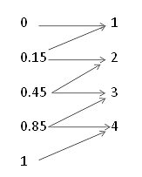
Figure 6.5 Creating table_array for V-lookup
Our requirement is as follows. If generated random number is between 0 and 0.15, Vlookup function should return 1, if it is between 0.15 and 0.45 return 2, if it is between 0.45 and 0.85 return 3 else return 4. This requirement is depicted in figure using arrows.
When ‘not_exact_match’ argument of vlookup function is true, and index number is 2 (signifying that the function should select a value from second column of the table_array) Vlooup function works as follows. Let the ‘look up value’ , the first argument of the function be 0.5. The vlookup function, at first, come down along first column and finds the highest number less than 0.5. In the first column the highest number less than 0.5 is 0.45 which is on third row. It then move along third row and select 3 (from the 2nd column) and return that value.
Figure 6.7 below shows how vlookup function works.
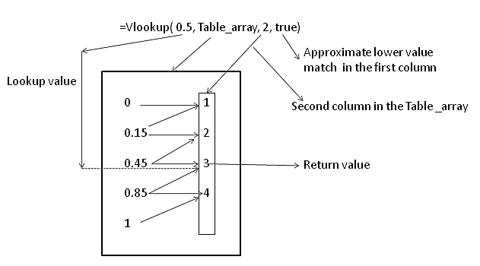
Figure 6.6 How Vlookup function works ?.
Experiment No:5 Generate 1000 random numbers from the following discrete distribution (see table 6.2). Count and show frequency and proportion of each number generated.
Table 6.2
x | 1 | 2 | 3 | 4
P(x) | 0.15 | 0.3 | 0.4 | 0.15
Step 1: Enter the headings ‘Uniform_R_No’ in A1,’ and Discrete_R_No’ in B1
Step 2: Enter headings ‘Cum_prob’ in E3, ‘Variable_x’ in F3, ‘Count’ in G3 and ‘Proportion’ in H3
Step 3: Enter cumulative probability values in E4:E7 and x values in F4:F7 as in figure 6.7 below. Note that last cumulative probability value ‘1’ is not required. To any lookup value greater than 0.85, the function will return 4.
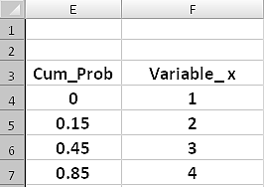
Figure 6.7 look up table for experiment No: 5
Step 4: Select the rectangular array (or range) E4:F7 containing cumulative probability values and variable values. Enter ‘table_array’ in the name box located at the left corner of the Excel window and press Enter key (this you must make sure). We can now refer the range E4:F7 by this name in any formula in this sheet. table_array stores the absolute address $E$4:$F$7. See the figure 6.8 below for the location of name box in excel window.
Note: while entering table_array do not put quote mark
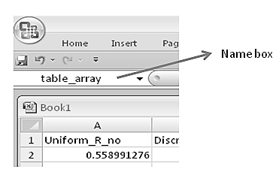
Figure 6.8 Naming a group of cells
Step 5: Enter =rand( ) in A2, = vlookup(A2,table_array,2,true) in B2
Step 6. Select A2:B2 and drag the fill handle to B1001. This will generate required discrete random numbers in column B. Column A will contain random numbers from uniform U(0,1) distribution.
Step 7: Enter =countif($B$2:$B$1002,F4) in G4 and drag the fill handle to G7. This is to count the number of each discrete variable values generated.

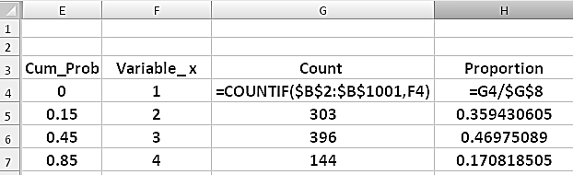
Figure 6.9 usage of ‘Countif’ function
Step 8: Enter the string ‘sum of count’ in F8 and formula =sum(G4:G7) in G8 . This sum should be 1000 since we generated 1000 numbers.
Step 9: Enter formula =G4/$G$8 in H4 and drag down fill_handle to H7 . This is to compute the proportion of each number generated.
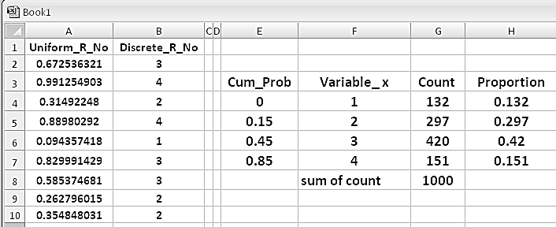
Figure 6.10 Final output of Experiment No:5
Step 10: Press function key F9 and see that proportion of each number generated is very close to the given probability distribution. That is, the proportion of 1’s is around 0.15, proportion of 2’s is around 0.3, proportion of 3’s is around 0.4 and proportion of 4’s is around 0.15. This proportion will approach the actual value if we generate large number of random variates. See figure 6.10
Note: The process of generating random numbers from a given distribution is also called “sampling”. The set of values obtained in one run is called a “sample”. Pressing function key F9 produces another ‘sample’.
Exercise No: 1 To generate random numbers from the following probability distribution given in Table 6.3 using vlookup, create a lookup table
Table 6.3
x | 2 | 4 | 6 | 8 | 10
P(x) | 0.1 | 0.2 | 0.4 | 0.2 | 0.1
Ans : See figure 6.11
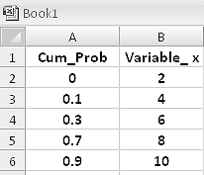
Figure 6.11 Lookup table for Exercise No:1
Use of hlookup
Hlookup work in the same way as vlookup except that hlookup search along first row of table_array and then move vertically to pick the return value. For the probability distribution given in Table 6.4, figure 6.12 shows how hlookup function works.
Table 6.4
x | 1 | 2 | 3 | 4
P(x) | 0.15 | 0.3 | 0.4 | 0.15

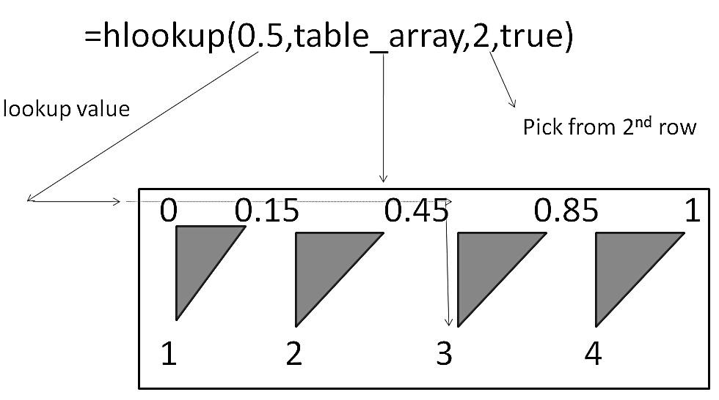
Figure 6.12 How hlookup function works
6.4 A geometric view of discrete Random number Generation process
We have seen that to generate random numbers from a discrete distribution we need to use cumulative probability distribution function. The whole process when viewed geometrically allow us to extend it for generation of random numbers from continuous didtribution.
Consider the following probability distribution function and associated cumulative distribution function (see Table 6.5) .
Table 6.5
x | 1 | 2 | 3 | 4 | 5
f(x) | 0.2 | 0.2 | 0.2 | 0.2 | 0.2
F(x) | 0.2 | 0.4 | 0.6 | 0.8 | 1

At first, let us mathematically express the Cumulative distribution function and then draw a curve with random variate on x-axis and the cumulative distribution on y-axis.
For x < 1 , F(x) = 0. At x = 1 , F(x)=0.2 and remain at 0.2 till x =2 and so on. The Cumulative distribution function can be described as
F(x) = 0 , for x < 1
F(x) = 0.2 , for 1≤ x < 2
F(x )= 0.4 , for 2≤x<3
F(x) = 0.6 , for 3≤x<4
F(x) = 0.8 , for 4≤x<5
F(x) = 1 , for x = 5
Figure 6.13 shows the random variate x versus cumulative distribution function.
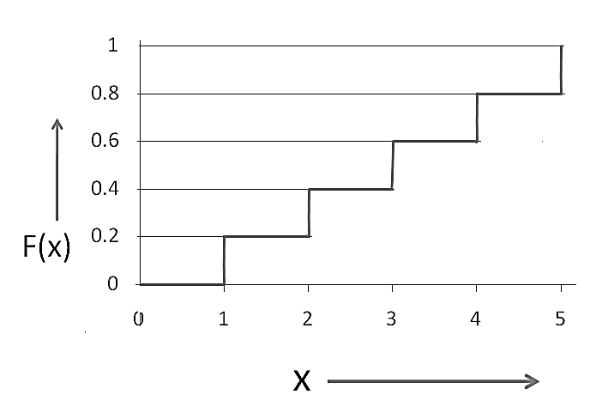
Figure 6.13 Cumulative distribution function
The process of generating random numbers from a given distribution which we have seen earlier can now be visualized in a geometric way. We generate U(0,1) random number representing the value of the cumulative distribution function F(x) = y and place it on the y-axis. Next, from that point we draw a line parallel to the x-axis till it crosses distribution function. From the point at which the line crosses the Cumulative distribution function curve, drop a line parallel to y-axis to get ‘x’ for which F(x)=y. Note that here x can take only integer values ranging from 1 to 4.
Thus mathematically, the generated uniform random number is taken to be F(x).
That is F(x) = rand( ) = y. Through cumulative disibution function curve, we find
x = F⁻¹(y). This x is the required discrete valued random variate.

Figure 6.14 illustrate the process. Let the unoform random variable generated be 0.7. We put it on y axis and find its inverse mapping value by projecting the value on x-axis through the cumulative distribution function.
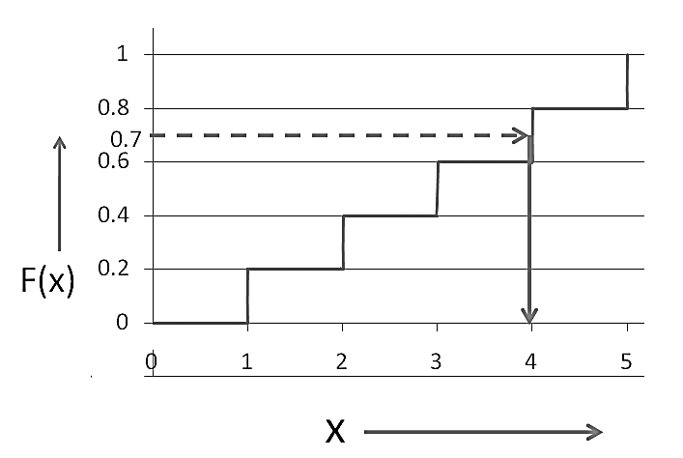
Figure 6.14 visualization of random number generation as an inverse look down process
6.5 Generating random numbers from continuous distributions
We extend the idea discussed so far to continuous valued probability density functions. In this case, the cumulative distribution function(CDF) - F(x) - is a smoothly varying function rather than an abruptly jumping step function. CDF of a generic distribution function 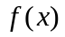 is given by 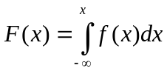 . ( This is area under curve from to x . F(x) value start from zero and end up in 1 since total area under a probability density function is 1. A typical CDF looks like as shown in figure 6.15. Different probability density functions will have different CDF. Thus CDF completely characterizes a probability distribution.

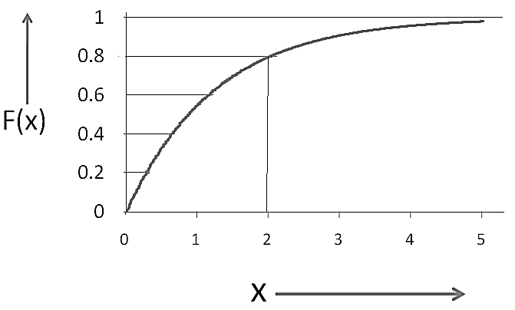
Figure 6.15 Inverse look down process for continous probability distribution
As in discrete case, to generate random number from the required continuous distribution function, first we draw cumulative distribution function. Then we generate a random number from U(0,1) and place it on the F(x) axis. Finally we find the inverse mapping x with respect to F(x) function curve. For example, let the random number be R=0.3 . Place it on the y-axis. Find its image on x-axis through F(x) curve i.e.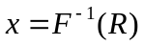. This method of generating random numbers is called Inverse transformation metethod . There are distributions for which F(x) is available in analytical form (i.e., F(x) is readily computable function of x) . Examples of such probability distributions are 1) Exponential distribution 2) weibull distribution 3) Triangular distribution. For these distributions, we need not compute and keep F(x) curve in advance.
6.5.1 Generating random numbers from Exponential distribution
For exponential, we have
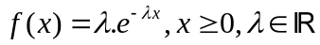
The cumulative probability distribution function F(x) of the exponential function is nothing but the area under the probability density curve from 0 to x. It is obtained by the following integration:
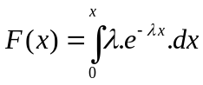
On integration:
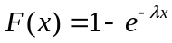
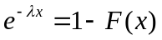
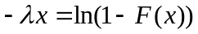
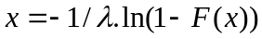
Like F(x), since 1-F(x) is always a number between 0 and 1, we can use a simplified formula, 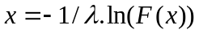, where, F(x) is the taken as uniform random number. Thus equation 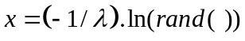 is used to generate the sample values from exponentially distributed random variable X .
6.5.2 Generating random numbers from Normal (Gaussian) Distribution
The density function of standard normal distribution( denoted as N(0,1) whose mean is 0 and variance is 1) is given by
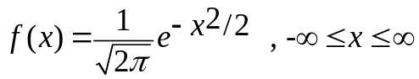 . This distribution, however, donot permit direct inversion since 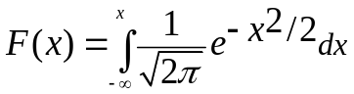 do not have closed form expression. F(x) can be computed only by numerical method.
Excel, provides a direct function for generating random number from gaussian distribution with given mean and standard deviation. The syntax of the formula is =norminv(rand( ), mean, standard_deviation)
Boxmuller formula for generating Random numbers from N(0,1)
The Box Muller method is a brilliant trick to overcome the inversion problem of cumulative gaussian distribution function by producing two independent standard normals from two independent uniforms. It is based on variable transformation technique that is usually employed for finding density function of ‘a function of random variable’. Interested Readers may search google for its derivation. Let U₁ and U₂ be two independent uniformly distributed random number. Two Gaussain N(0,1) random numbers are

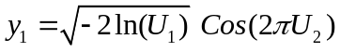 and 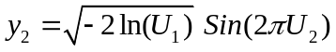
In excel we need to use only one of this formula. We write the formula as
To generate gaussian random numbers with mean 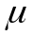 and standard deviation 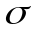 , we write the formula as
6.6 Summary
Computer Simulation is one of the key technlogy of modern era. Since any real system is inherently random in nature in terms of its parameters and input is also random in nature (even if the input is deterministic, it will be subjected to ambient noise) to certain degree , its modelling and simulation requires random number generation. This chapter dealt on theory behind random number generation and its implementation in Excel. Using excel’s rand( ) function it is possible to generatae random number from all other distribution. These techniques will be used in later chapters for generating fractals.
6.7 Problems
1) Generating Gaussian random numbers
Generate 1000 random numbers from Normal distribution with mean μ= 100 and standard deviation σ = 5 . After generating data, compute the following
- Find mean and standard deviation of the generated data
- Find % of data falling between 95 and 105 (i.e., μ ±σ)
- Find % of data falling between 90 and 110 (i.e., μ ±2σ)
- Find % of data falling between 85 and 115 (i.e., μ ±3σ)
2) Generating random numbers from exponential distribution
Generate 1000 random numbers from exponential distribution with parameter λ=0.1 . After generating data, compute the following
- Mean and standard deviation of the data generated
- Find number of numbers falling in intervals of 5 units starting from 0
- Based on data from question 2, draw a histrogram. How the histogram look like. Any resemblence with exponential function
3) Generating random numbers from Gaussaian distribution using Boxmuller equation
Generate 1000 random numbers from Normal distribution with mean μ= 100 and standard deviation σ = 5 .
4) Generate 100 Uniform random numbers from -1 to 1
5) Using simulation show that area inside unit circle approaches 3.14
6) What is the vlook up table required for following discrete distribution
x | 1 | 3 | 6 | 7 | 10
P(x) | 0.3 | 0.2 | 0.1 | 0.2 | 0.2
7) What is the Hlook up table required for following discrete distribution
x | -3 | 0 | 2 | 3 | 4
P(x) | 0.3 | 0.2 | 0.1 | 0.2 | 0.2
6.8 References
[1] Wendy L. Martinez, Angel R. Martínez, Computational statistics handbook with MATLAB, Chapman and Hall , 2002
[2] James E. Gentle, Elements of computational statistics, springer 2002
[3] William Jo Kennedy, James E. Gentle, Statistical computing, M. Dekker, 1980

